Supporting information of
Auramine-O dye abnormal Stokes shift in aqueous solution due to J-aggregate formation

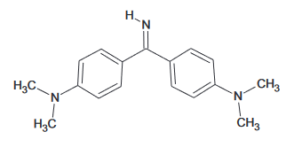 | 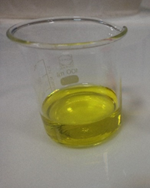
Scheme 1. Chemical structure of Auramin-O with Canary yellow color

Materials:
4-[4-(dimethylamino) benzenecarboximidoyl]-N, N-dimethylaniline; hydrochloride; CAS: 2465-27-2 (Auramine-O), SnCl₂, NaOH, HCl, H₂SO₄ and HNO3 were purchased from Sigma-Aldrich. Used materials were analytical grade. Solutions with different pH were prepared by adjusting them with NaOH and HCl solutions. UV-vis. measurements and photoluminescence (PL) spectra were taken with biochrom of Biowave series and JASCO FP-6500 instruments, respectively. Quartz cuvettes used in spectrophotometric and PL measurements. The strength of the magnetic field of handheld magnet was 25 mT.

Results:
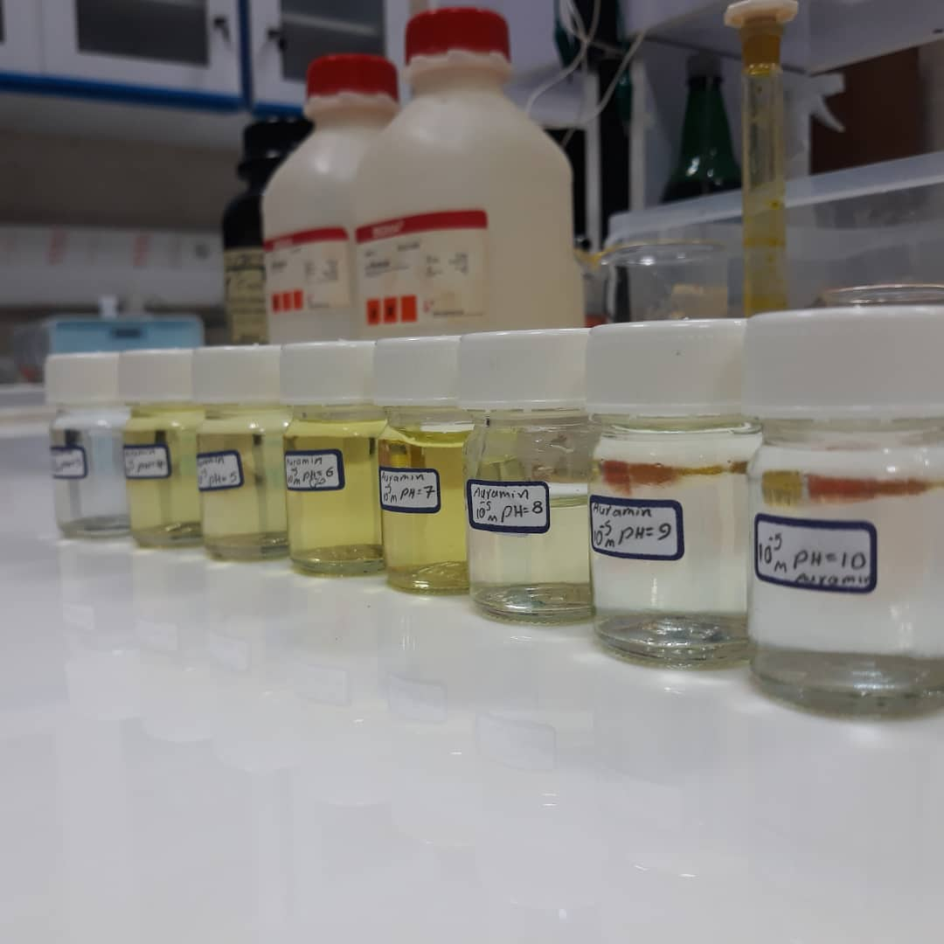
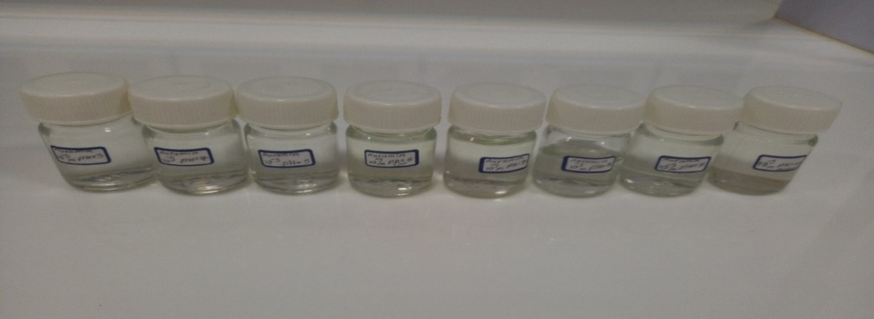
Figure 1. pH dependence of Au-O aqueous solution (1×10⁻³ M) color from pH=3 (left) to pH=10 (right) by one step pH increment

Figure 2. UV-vis. spectra of Au-O (1×10⁻³ M) aqueous solution with different pH

Figure 3. pH dependent of UV-vis. spectra absorbance maximum of Au-O (1×10⁻³ M) aqueous solution

Figure 4. PL spectra of Au-O (1×10⁻³ M) aqueous solution with different pH (with excitation wavelength 310 nm)

Figure 5. pH dependent of the PL spectra maximum of Au-O (1×10⁻³ M) aqueous solution with excitation wavelength 310 nm

Scheme 2. Proposed mechanism for pH effect on Au-O dye solution florescence

Figure 6. pH dependent of absorbance spectra of Au-O (1×10⁻³ M) aqueous solution
at two maxima of 380 nm and 430 nm

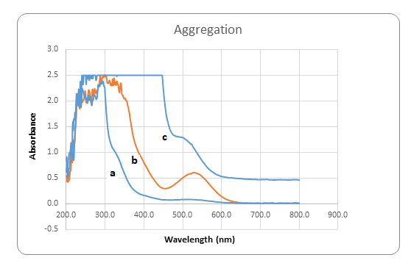
Figure 7. UV-vis. spectra of Au-O in aggregate form in acidic aqueous solution;
a) 1×10⁻² M. b) 3×10⁻² M and c) 5×10⁻² M (pH=0.5, with locally λ_{max}=537 nm)

Figure 8. UV-vis. and PL spectra of Au-O in neutral solution (1×10⁻³ M, pH=6 and yellow color)

Figure 9. UV-vis. and PL spectra of Au-O aggregate in acidic aqueous solution
(1×10⁻² M, pH=0.5 and red color)

Figure 10. Absorbance and PL spectra of Au-O aggregate in H₂O
and D₂O (3×10⁻² M, pH=0.5)
Figure 11-a. PL spectra of Au-O aggregate in ordinary water (3×10⁻² M, pH=0.5) along with
PL-max movement
Figure 11-b. PL spectra of Au-O aggregate in heavy water (3×10⁻² M, pH=0.5) along with
PL-max movement

Figure 12. PL spectra of Au-O in water in the presence and absence of a handheld magnet
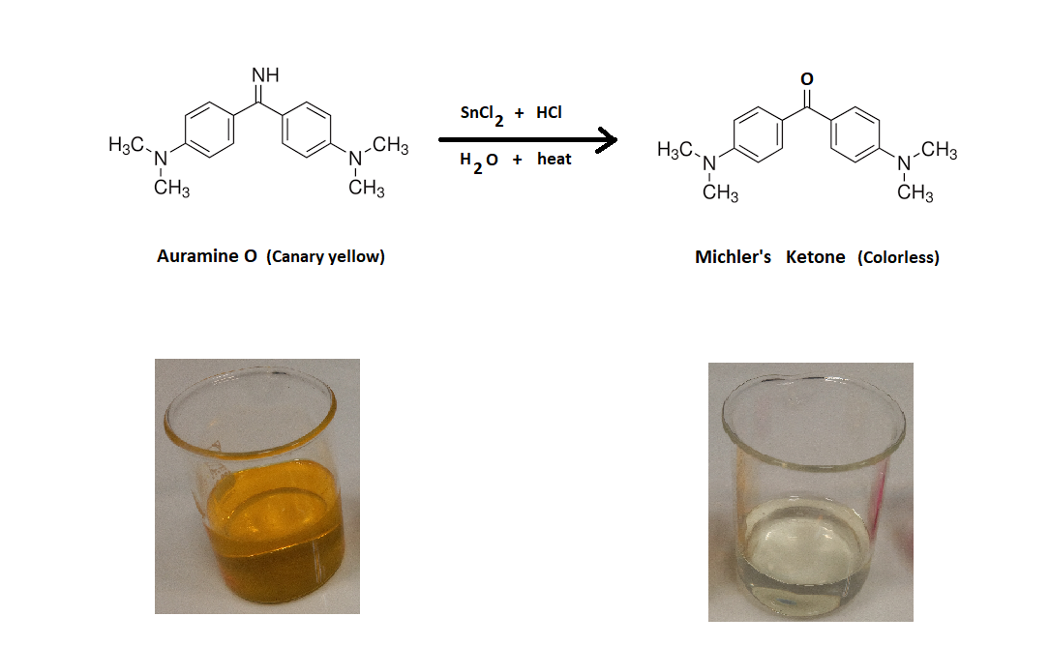
Scheme 3. Reduction of Au-O to Michler’s ketone via Stephen’s method
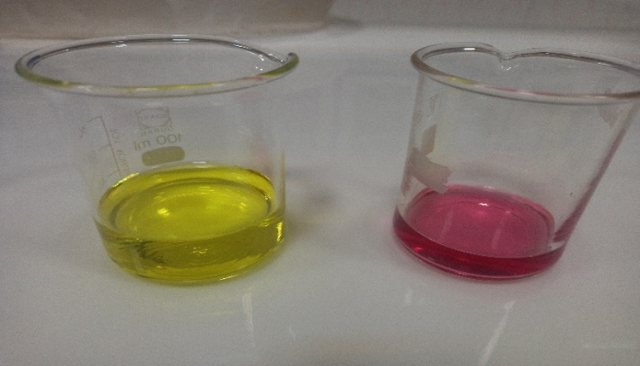
Figure S1-a. Au-O colorant neutral solution (pH=6) as yellow color (left) and in aggregate form in acidic solution (3×10⁻² M and pH=0.5) as red color (right)

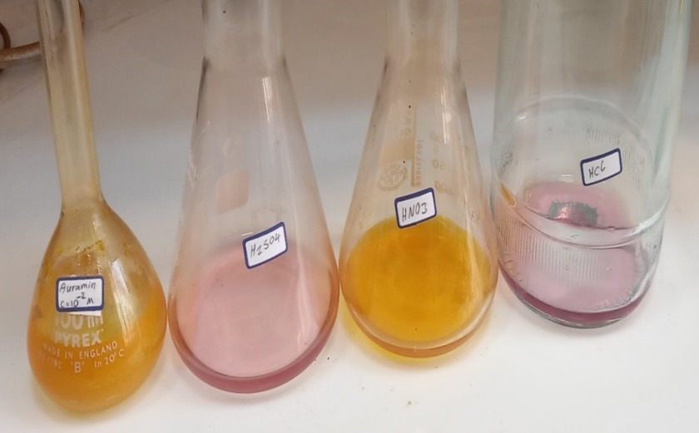
Figure S1-b. Au-O colorant neutral solution (3×10⁻² M and pH=6) as yellow color (left) and in aggregate form in acidic solution (3×10⁻² M and pH=0.5) as red color
(right, in H₂SO₄ and HCl), was decomposed in HNO₃

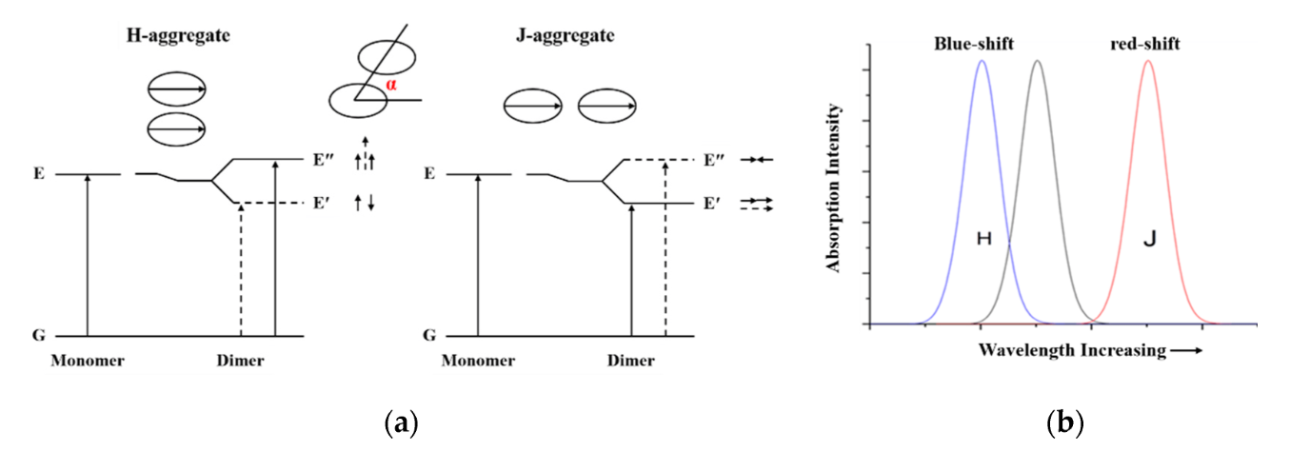
Figure S2. Kasha exciton theory based transitions for molecular aggregate

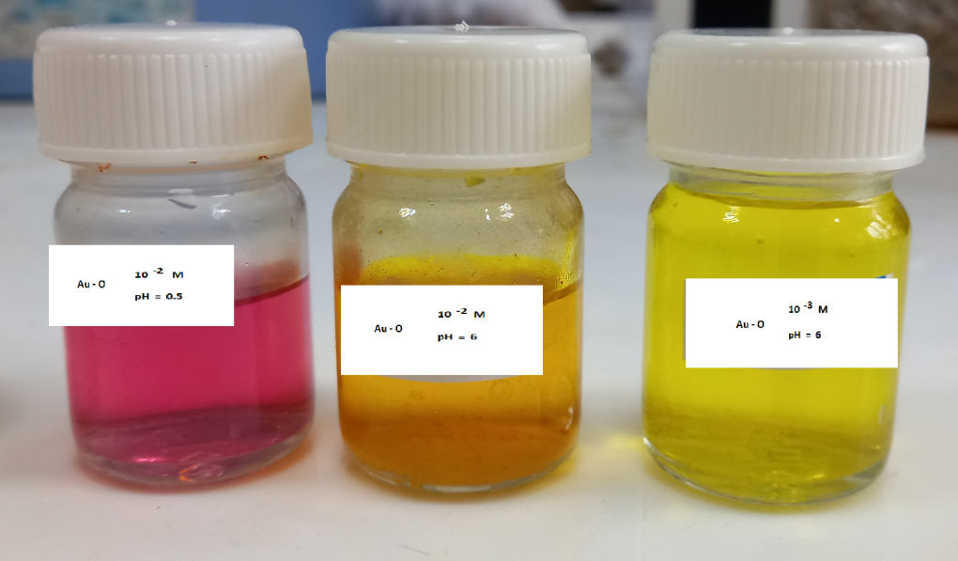
Figure S3. Au-O in different solution and pH which it shows red and yellow colors

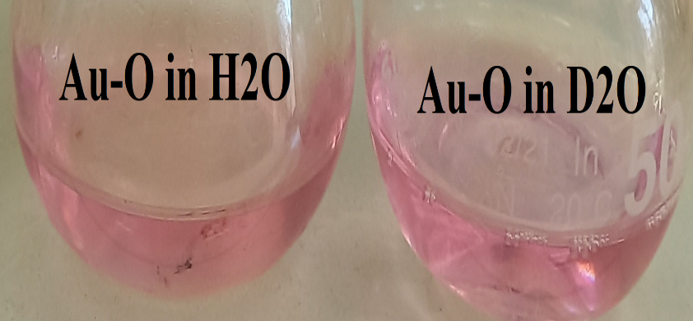
Figure S4. Au-O aggregate in H₂O and D₂O (3×10⁻² M, pH=0.5)

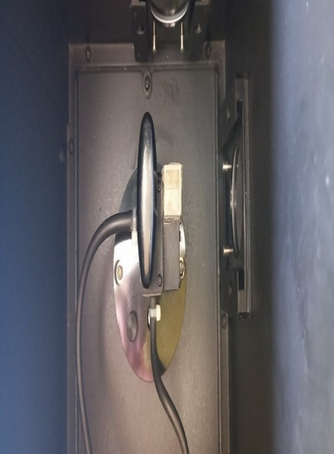
Figure S5. Set up of photoluminescence together with a handheld magnet (25 mT) used for Au-O PL in water

